Eg: Copy_Of_String_Eg43
// go through the code

Eg: Capital_String_Eg44
// go through the program.

Eg: SmallerCase_String_Eg45
// go through the program

Eg: Opposite_Case_Converting_Eg46
// go through the program

Eg: Reverse_The_String_Eg47
// go through the program

Eg: Word_Palindrome_Eg48
// go through the code

Eg: String_Eg49
// go through the program

Eg: String_Eg50
// go through the program

Eg: String_Eg51
// go through the program

Eg: String_Eg52
🔑 CORE POINT (MEMORIZE THIS)
s1 = s2;
➡ RHS is evaluated FIRST
➡ The value of RHS is assigned to LHS

What is the “value” here?
- s2 is a reference variable
- Its value is a memory address (reference)
So internally Java does:
s1.reference = s2.reference;

What happens because of this?
- s2 → ❌ NOT changed
- s1 → ✅ overwritten
- ❌ No object is copied
- ❌ No new object is created
- ✅ Both references now point to the SAME object

🔁 One-Line Interview Answer
In s1 = s2, Java evaluates the RHS first and assigns its reference value to the LHS. Only the LHS changes.

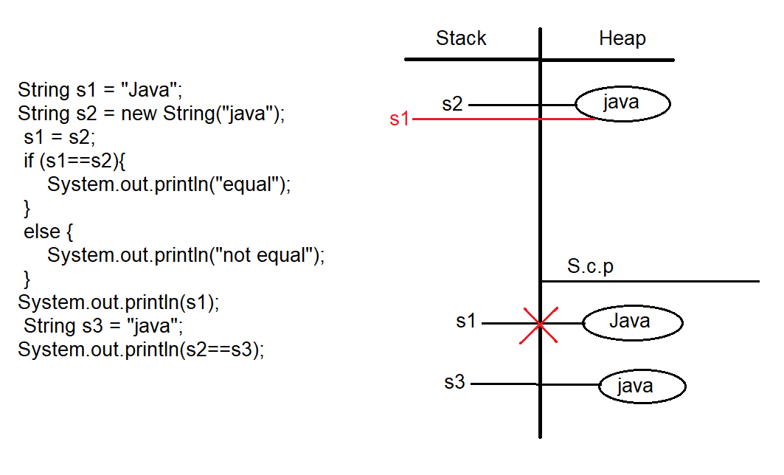

Eg: String_Eg53
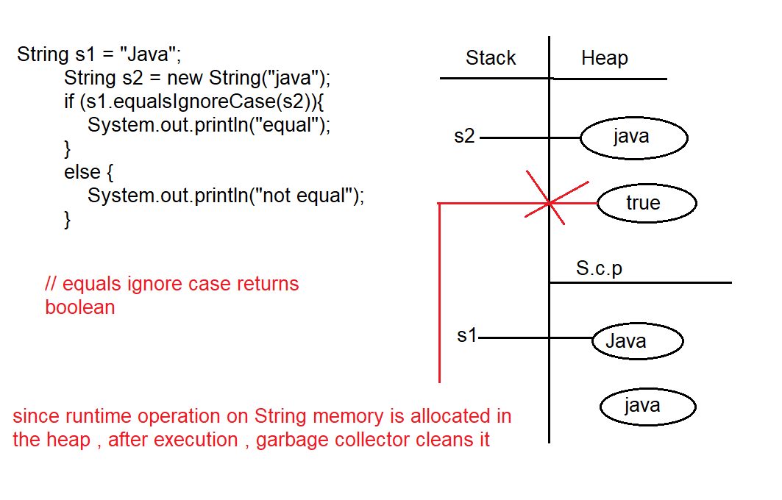

Eg: String_Eg54
// go through the code

Eg: String_Eg55
// go through the code

Eg: String_Eg56
// go through the program

Eg: String_Eg57
// go through the program

Eg: String_Eg58
// go through the code

Eg: String_Eg59
// go through the code

Eg:String_Eg60
// go through the code

Eg: String_Eg61
// go through the code

Eg: String_Eg62
// go through the code

Eg: String_Eg63
// go through the code

Eg:String_Eg64
// go through the code

Eg: String_Eg65
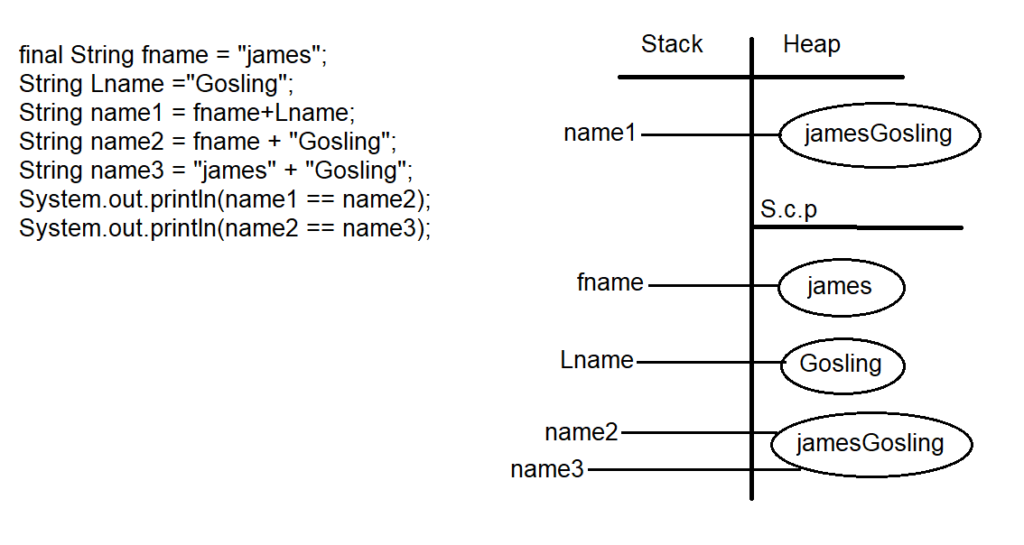

Only string literals and final variables with compile-time constant values are evaluated during compilation; everything else is evaluated at runtime ( discussed earlier)

Eg: Palindrome_Using_String_Methods
// go through the code

Eg: Converting _String_To_Char_Array
// go through the program

Eg: Anagram
📝 Anagram — Short Note
An anagram is a word or phrase formed by rearranging the letters of another word or phrase,
using the same characters exactly once.
- Spaces are usually ignored
- Letter case is usually ignored
✅ Examples
- listen → silent
- a gentle man → elegant man
- race → care

Eg: panagram
📝 Pangram — Short Note
A pangram is a sentence that contains every letter of the English alphabet (A–Z) at least once.
✅ Example
“The quick brown fox jumps over the lazy dog”
✔ This sentence contains all 26 letters from a to z.
❌ Not a Pangram
“Hello world”
(Does not contain all letters)

Eg: String_Eg66
// go through the code

Eg: String_Eg67
// go through the code

Eg: String_Eg68
// go through the code

Eg: String_Eg69
// go through the code

Eg: String_Eg70
// go through the code

Eg: String_Eg71
🧠 Key Rules (Perfect for Notes)
- String.join() → delimiter + non-null elements only
- delimiter must NOT be null
- Any null element → NullPointerException
- String.join("-", "a", "b") → works
- String.join("-", null) → ❌ error

Eg: String_Eg72
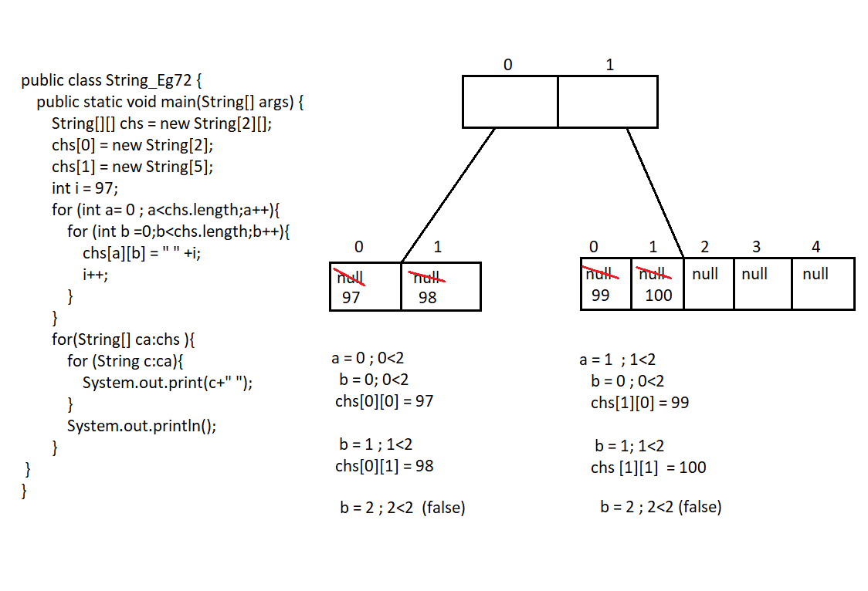
🧠 Step 1: Understanding the Array Structure
String[][] chs = new String[2][];
This creates:
- 2 rows
- Column sizes NOT decided yet
Then:
chs[0] = new String[2]; // row 0 → 2 columns
chs[1] = new String[5]; // row 1 → 5 columns
So the array looks like this:
Row 0 → [ ?, ? ]
Row 1 → [ ?, ?, ?, ?, ? ]
This is called a jagged array (rows have different sizes).

🧠 Step 2: Value of i
int i = 97;
97 is important because:
'a' = 97 (ASCII)
But here you are storing numbers as strings, not characters.

🧠 Step 3: The TRICKY PART (Nested Loops)
for (int a = 0; a < chs.length; a++) {
for (int b = 0; b < chs.length; b++) {
chs[a][b] = " " + i;
i++;
}
}
🔴 The hidden issue is HERE:
b < chs.length
- chs.length = 2 (number of rows)
- But column size is different for each row
So inner loop runs only 2 times, even for row 1 (which has 5 columns).

🧠 Step 4: What Actually Gets Filled
Row 0 (size = 2)
b = 0 → chs[0][0] = " 97"
b = 1 → chs[0][1] = " 98"
Row 1 (size = 5)
b = 0 → chs[1][0] = " 99"
b = 1 → chs[1][1] = " 100"
❌ Columns 2, 3, 4 of row 1 are never assigned
➡ They remain null

🧠 Final Array State
Row 0 → [" 97", " 98"]
Row 1 → [" 99", " 100", null, null, null]

🖨 Output
97 98
99 100 null null null

Eg: String_Eg73
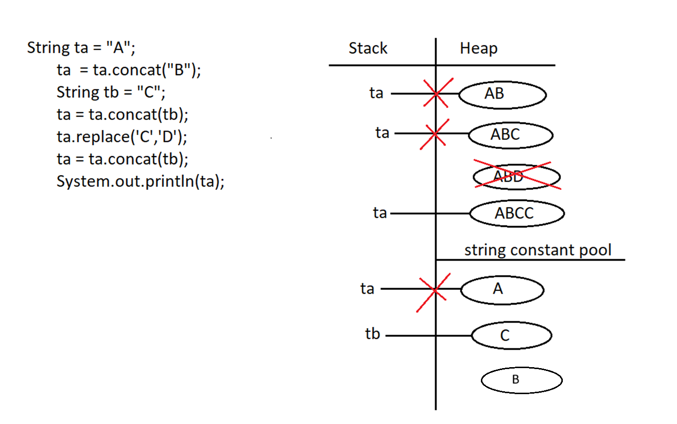

Eg: String_Eg74
// go through the code

Eg: String_Eg75
// go through the code

